Walmart Sales Analysis (2019–2023)

**-- EDA**

describe walmart_sales;

ALTER TABLE walmart_sales

MODIFY COLUMN date DATE;

SELECT DISTINCT date

FROM walmart_sales

WHERE STR_TO_DATE(date, '%Y-%m-%d') IS NULL

OR date IS NULL

OR date = '';

UPDATE walmart_sales

SET date = STR_TO_DATE(date, '%Y-%m-%d');

Select * from walmart_sales;

**Data correction**

update walmart_clean_data

SET date = STR_TO_DATE(date, '%Y-%m-%d');

ALTER TABLE walmart_clean_data

MODIFY COLUMN date DATE;

update walmart_clean_data

set time = str_to_date(time, '%H:%i:%s');

ALTER TABLE walmart_clean_data

MODIFY COLUMN time time;

**describe walmart_sales;**

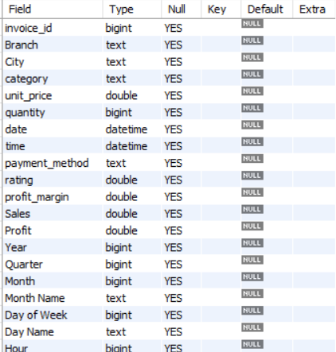

**-- KPIs**

select year(date) as Year,

count(*) as Total_Transactions,

sum(Sales*profit_margin) as Total_Revenue,

sum(profit_margin) as Profit_Margins,

sum(Profit) as Total_Profit,

avg(rating) as Avg_rating from walmart_sales

group by year(date)

order by Year;

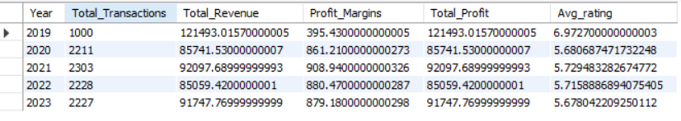

**-- Count total records:**

select count(*) as Total_records from walmart_clean_data;

**-- Count payment methods and number of transactions by payment method**

select payment_method , count(*) as Total_transactions from walmart_clean_data

group by 1;

**-- Count distinct branches**

select * from walmart_clean_data;

select count(distinct branch) from walmart_clean_data;

**-- Find the minimum quantity sold**

SELECT MIN(quantity) FROM walmart_clean_data;

**-- Q1: Find different payment methods, number of transactions, and quantity sold by payment method**

select payment_method,

count(*) as Tansactions,

sum(quantity) as Qty_Sold

from walmart_sales

group by payment_method

order by Tansactions desc;

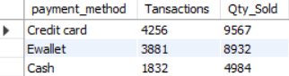

**-- Q2 Identify the highest rated category in each branch. displaying the branch, category and avg rating**

select branch, category,avg(rating) as Avg_Rating

from walmart_sales

group by branch,category

order by Avg_Rating desc;

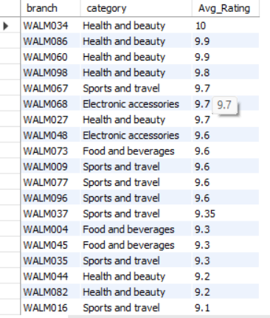

**-- Q3 Identify the busiest day for each branch based on the number of transactions**

**select * from walmart_sales;**

**describe walmart_sales;**

SELECT

DATE(date) AS Day,

Branch,

COUNT(*) AS Transactions

FROM

walmart_sales

GROUP BY

DATE(date), Branch

HAVING

COUNT(*) = (

SELECT

MAX(transaction_count)

FROM (

SELECT

DATE(date) AS day,

Branch,

COUNT(*) AS transaction_count

FROM

walmart_sales

GROUP BY

DATE(date), Branch

) AS subquery

);

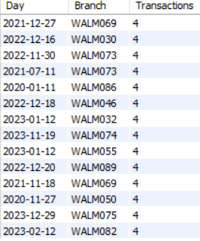

**-- Q4: Calculate the total quantity of items sold per payment method**

select payment_method, sum(quantity) as Total_qty_sold from walmart_sales

group by 1;

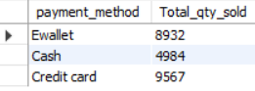

**-- Q5 determine the average, minmum and maximum rating of a product for each city.**

**-- list the city, avg rating, minimum_rating, max_rating**

select city, Avg(rating) as Avg_Rating,

min(rating) as Minimum_Rating,

max(rating) as Maximum_rating

from walmart_sales

group by city

order by Avg_Rating desc;

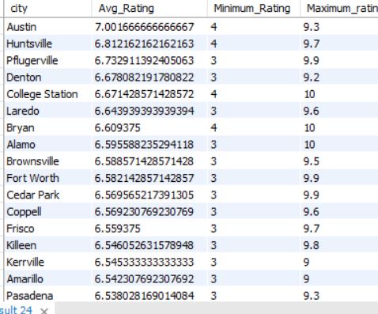

**-- Q6 calculate the total profit for each category by considering tota_profit as**

**-- (Sales * profit margin), list category and total profit ordered from highest to lowest profit**

select category,

round(sum(Sales * profit_margin),2) as Total_Profit

from walmart_sales

group by category

order by Total_Profit desc ;

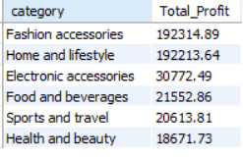

**-- Q7 determine the most common payment method for each branch**

**-- display branch and paymentmentod**

select branch as Branch,

count(*) as Transaction,

payment_method as Most_uses_Payment_method

from walmart_sales

group by Branch,Most_uses_Payment_method;

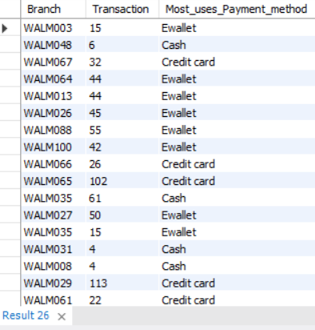

**-- Q8 categorize sales into 3 groups moring, afetnoon and evening**

**-- find out which of the shift and numbert of invoices**

select case

when hour(time)<12 then 'Morning Shift'

when hour(time) between 12 and 17 then 'Afternoon Shift'

else 'Evening Shift'

end as Day_Shift, sum(quantity) as Total_qty_sold from walmart_sales

group by 1;

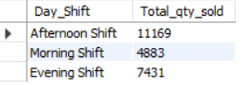

**-- Q9 Find Sales By month**

select month(date) as Month,monthname(date) as Month_Name ,sum(Sales) as Sales_By_Month

from walmart_sales

group by month(date),monthname(date)

order by month(date);

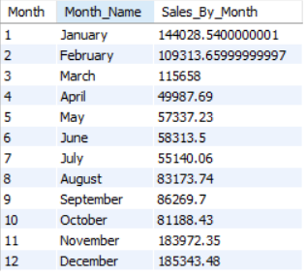

**-- Q10 Find Sales & Profit By quater**

Select quarter(date)as Quarter,sum(Sales) as Sales,sum(Profit) as Profit

from walmart_sales group by Quarter, quarter(date)

order by quarter(date), Quarter;

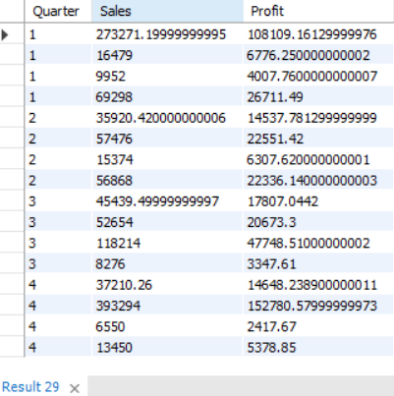

**-- Q11 Get the sales by category**

Select category, sum(Sales) as Sales ,

(SUM(Sales) / (SELECT SUM(Sales) FROM walmart_sales)) * 100 AS Sales_Percentage

from walmart_sales

group by category;

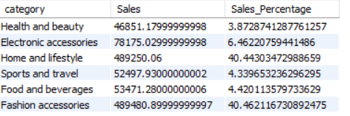

**-- Q12 Get the Qty Sold by category**

Select category, count(quantity) as Qty_Sold,

round( (count(quantity) / (SELECT count(quantity) FROM walmart_sales)) * 100,2) AS Qty_Sold_Percentage

from walmart_sales

group by category;

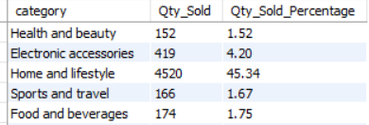

**-- Q13 Get the Profit by category**

Select category, sum(Profit) as Profit,

round( (sum(Profit) / (SELECT sum(Profit) FROM walmart_sales)) * 100,2) AS Profit_Percentage

from walmart_sales

group by category;

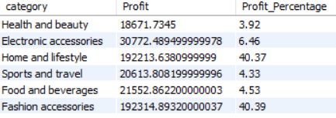

**-- Q14 Get the Sales by hour**

select year(date) as Year, month(date) as Month,

monthname(date) as Month_Name ,hour(time) as Hour,

sum(sales) as Sales from walmart_sales

group by year(date), month(date),monthname(date) ,hour(time)

order by year(date), month(date);

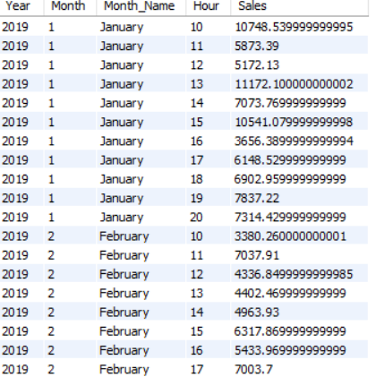

**-- Q15 Get the orders by hour**

select hour(time) as Hour, count(quantity) as Orders from walmart_sales

group by hour(time)

order by hour(time);

